CURRICULUM VITAE
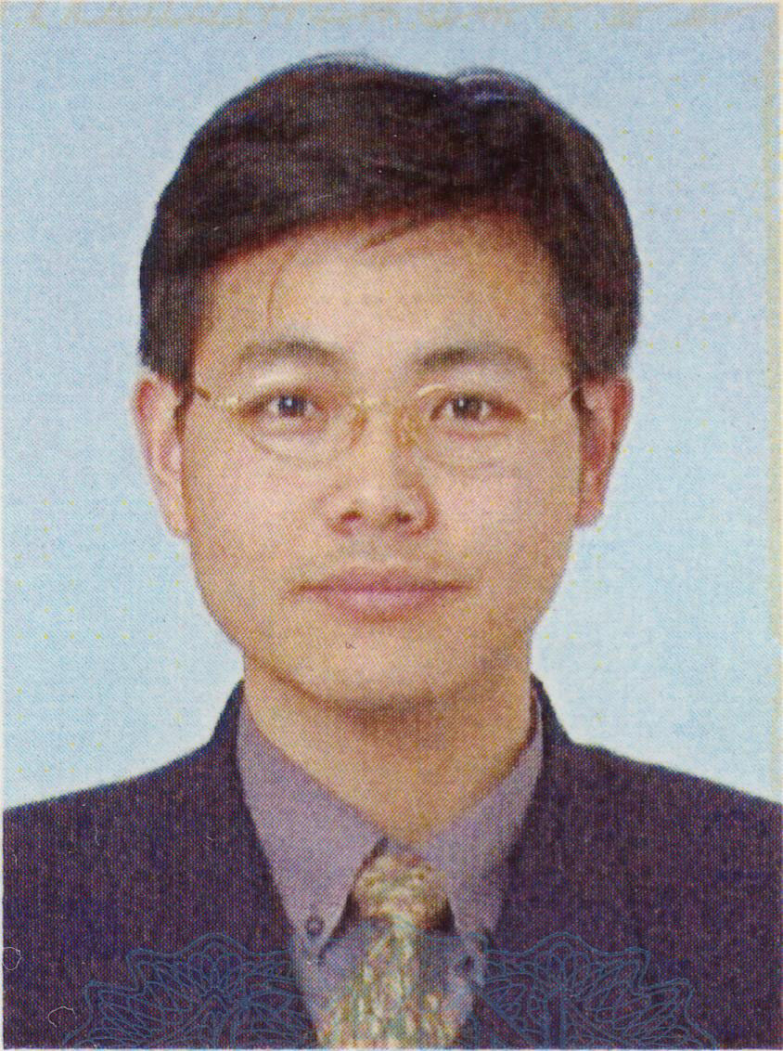
Metallurgical Processing Group
Steel Research Center
National Institute for Materials Science
1-2-1, Sengen, Tsukuba, 305-0047, Japan
Tel: +81-29-859-2233 Fax: +81-29-859-2201

Personal Information
Name | Zhongzhu Liu
Gender | Male
Date of Birth | March 9,1970
Place of Birth | Wuhan, Hubei Province, China
Health | Excellent
Nationality | People's Republic of China
Marital Status | Married
Character | obliging, conscientious, hardworking, independent, cooperative
Hobby | novel, badminton, tennis, music
E-mail Address | lzzu@yahoo.com, LIU.Zhongzhu@nims.go.jp

Education Experience
1998.9~2002.3: School of Metallurgical and Ecological Engineering, University of Science and Technology Beijing, Ph.D. in Metallurgical Engineering.
1996.9~1998.9: School of Metallurgical and Ecological Engineering, University of Science and Technology Beijing, M.S. in Metallurgical Engineering.
1988.9~1992.6: Department of Metallurgy and Materials, Chongqing University, B.S. in Metallurgical in Engineering.

Working Experience
2002.5~current: Post doctor research fellow, Metallurgical Processing Group, Steel Research Center, National Institute for Materials Science, Japan.
1992.7~1996.9: Assistant Engineer, Wuhan Iron and Steel Corporation (WISCO).

Fields of Research Interests
Casting and solidification, inclusion and second phase particles, structure and properties, phase transformation of metals and alloys

Skills
English: good in listening, speaking, reading and writing abilities
Japanese: Fair in reading ability
Familiar with SEM and TEM operation.

References
Kotobu Nagai
Director-General, Steel Research Center, National Institute for Materials Science.
1-2-1 Sengen, Tsukuba, Ibaraki 305-0047 JAPAN
Tel: +81-29-859-2102 Fax:+81-29-859-2101
E-Mail: NAGAI.Kotobu@nims.go.jp

Kaike Cai
Vice-President of Continuous Casting Committee, Chinese Society for Metals(CSM).
Professor of Metallurgy, School of Metallurgical and Ecological Engineering, University of Science and Technology Beijing.
30 Xueyuan Road, Haidian District, Beijing, 100083, P. R. CHINA.
Tel:+86-10-62332358 Fax:+86-10-62322845
E-mail: kaikecai@metall.ustb.edu.cn

List of Publications
- Zhongzhu Liu, Yoshinao Kobayashi, Kotobu Nagai. Effect of Phosphorus on Sulphide Precipitation and Ductility of Strip Casting Low Carbon Steel (to be published).
- Zhongzhu Liu, Yoshinao Kobayashi, Kotobu Nagai. Crystallography and Precipitation Kinetics of Copper Sulfide in Strip Casting Low Carbon Steel (Submitted to ISIJ International, receipt No. 2004 234).
- Zhongzhu Liu, Yoshinao Kobayashi, Kotobu Nagai. Effect of Nano-Scale Copper Sulfide Particles on the Yield Strength and Work Hardening Ability in Strip Casting Low Carbon Steel. Materials Transactions, Vol.45(2), 2004: 479-487.
- Zhongzhu Liu, Yoshinao Kobayashi and Kotobu Nagai. Precipitation Strengthening by Nano-sacle Copper Sulfide Particles in Strip Casting Low Carbon Steel. 埼玉工業大学若手研究フォーラム 第1回研究フォーラム---21世紀の新しい創造性を支えるハイ・テクノロジー, 2003: pp83-86.
- Zhongzhu LIU, Yoshinao Kobayashi, Kaike Cai. Precipitation of Sulfide on Oxide in Steel during Solidification. 7th Workshop on the Ultra-Steel: Requirements from New Design of Constructions. 2003: pp282-283.
- Fan Chen, Liu Zhongzhu, Cai Kaike. Research on Cleanliness of Steel Grade 45 Produced by BOF-LF-CC Process. Iron & Steel, Vol.38(3), 2003: 18-20.
- Jiang Hanxiang, Sun Shanchang, Zhang Tingbo, Zhao Xiuhua and Liu Zhongzhu. Smelting FeWMo Alloy with Aluminothermic and Silicothermic Process. Ferro-alloys,Vol.34(2), 2003:11-14.
- Zhongzhu Liu, Jun Wei and Kaike Cai. A Coupled Mathematical Model of Microsegregation and Inclusion Precipitation during Solidification of Silicon Steel. ISIJ International, Vol.42(9), 2002: 958-963.
- Zhongzhu Liu, Kejing Gu and Kaike Cai. Mathematical Model of Sulfide Precipitation on Oxides during Solidification of Fe-Si Alloy. ISIJ International, Vol.42(9), 2002: 950-957.
- Jiang Hanxiang, Sun Shanchang, Zhang Tingbo, Zhao Xiuhua and LIU Zhongzhu. Production of Ferro-alloy W-Mo-Fe by Silicon-aluminothermy. Journal of Chongqing University (Natural Science Edition), Vol.25 (6), 2002: 78-80.
- Liu Zhongzhu, Cai kaike. Research on the Cleanliness of Low Carbon Al-killed Steel during LD-RH-CC Process. Iron & Steel, Vol.36 (4), 2001:23-26.
- Liu Zhongzhu, Cai kaike. Entry of Continuous Casting, China Metallurgy Encyclopedia, Vol. Ironmaking and Steelmaking. Metallurgy Industry Publishing House, Beijing, 2001. pp333-337.
- Liu Zhongzhu, Cai kaike. Research on Surface Defects on Cold Rolled Silicon Steel Sheets, CSM 2001 Annual Meeting Proceedings, 2001:631-635.
- Liu Zhongzhu, Cai kaike. Research on the Cleanliness of Cold-rolled Grain-oriented Silicon Steel Produced by BOF-RH-CC Process. ASIA Steel International Conf.-2000, Beijing, Oct. 2000,Vol.C-Steelmaking: 553~559.
- Liu Zhongzhu, Cai kaike. Control of Inclusion during Continuous Casting. Proceedings of the 11th CSM Annual Steelmaking Conference, Beijing, China, Nov. 14~16, 2000: 298~303.
- Liu Zhongzhu, Cai kaike. Purity Steel Production Technology. Iron & Steel, Vol.35 (2), 2000:64~69.
- Wei Jun, Liu Zhongzhu, Cai kaike. Quality Control on High Carbon Steel Production by Steelmaking-Refining-Concasting Process. Steelmaking, Vol.16 (3), 2000: 46~51.
- Liu Zhongzhu, Cai kaike. Control of Cleanliness of liquid Steel during Continuous Casting. Clean Steel Production Technology Conference Proceedings, CSM, Beijing, Oct. 1999:104~117.
- Liu Zhongzhu, Cai kaike. Clean Steel and its Production Technology. China Metallurgy, 1999(5):12~15.
- Liu Zhongzhu, Cai kaike. Clean Steel and its Production Technology (Be continued). China Metallurgy, 1999(6):24~28.
- Jing Dejun, Liu Zhongzhu, Cai kaike. Influence of Peritectic Phase Transformation on the Solidification Shrinkage of Initial Shell in Continuous Casting of Steel. Journal of Iron and Steel Research, Vol.11 (3), 1999:9~13.
- Han Zhiqiang, Yuan Weixia, Liu Zhongzhu, Cai kaike. Strain Analysis Model for Continuously Cast Slab. Iron & Steel, Vol.34 (Suppl.), 1999: 621~624,570.
- Fang Dong, Liu Zhongzhu, Cai kaike. Optimum Process of RH treatment for Ultra-low Carbon Steel. Journal of University of Science and Technology Beijing, Vol.21 (5), 1999: 425~427,435.
- Wan Xiaoguang, Liu Zhongzhu, Cai kaike. The Behavior of Ar Bubbles in the Mould during Continuous Casting. The 6th CSM Annual Continuous Casting Conference Proceedings, June 1999, Wulumoqi: 53~57.

